## Quick Synopsis

To manage application complexity , js code needs to be broken down into smaller files.

Technologies used:

**RequireJS** - for managing js files along with their dependencies

**Grunt** - to concat, minify and build the final js which can be deployed for production.

## File structure

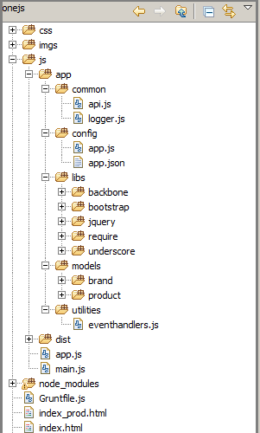

1. **index.html** : can be used in development environment
2. **index_prod.html** : is for production environement.
3. **main.js** : is the main file which loads other modules such as models, logger etc.
4. **app/common :**
   1. **api.js:** centralisedclass to make any AJAX calls.
   2. **logger.js:** simple logger class
5. **app/config:**
   1. **api.js:** contains all the application related config params.
6. **app/libs: contains all the third party libraries such as jQuery , bootstrap, requirejs etc**